**2CWK40: Designing the Ultimate Music App**

**By Edward Meek**

**Contents:**

**Chapter 1: Expert Testing………………………………………………………………………2 - 22**

Section 1.1: “My SUS Scores”………………………………………………………………………………………..2 - 12

Section 1.2: “My Qualitive Reflections”………………………………………………………………………13 - 16

Section 1.3: “My Heuristic Evaluations”………………………………………………………………………17 - 22

**Chapter 2: Prototyping…………………………………………………………………………23 - 32**

Section 2.1: “My Vision”………………………………………………………………………………………………23 - 25

Section 2.2: “My Test Plan”………………………………………………………………………………………………..26

Section 2.3: “My Low-Level Prototype”………………………………………………………………………………27

Section 2.4: “Test Results”…………………………………………………………………………………………..28 - 32

**Report Chapter 1: Expert Testing**

Section 1.1: “My SUS Scores”

Spotify:

|  |  |  |  |  |
| --- | --- | --- | --- | --- |
|  |  |  |  | **X** |

Strongly Disagree

Strongly Agree

1. I think I would like to use this system frequently.

4

2

3

5

1

|  |  |  |  |  |
| --- | --- | --- | --- | --- |
|  | **X** |  |  |  |

1. I found the system unnecessarily complex

4

2

3

5

1

|  |  |  |  |  |
| --- | --- | --- | --- | --- |
|  |  |  | **X** |  |

1. I thought the system was easy to use

4

2

3

5

1

|  |  |  |  |  |
| --- | --- | --- | --- | --- |
| **X** |  |  |  |  |

1. I think that I would need the support of a technical person to be able to use this system.

4

2

3

5

1

|  |  |  |  |  |
| --- | --- | --- | --- | --- |
|  |  |  |  | **X** |

1. I found the various functions in this system were well integrated.

1

4

2

3

5

|  |  |  |  |  |
| --- | --- | --- | --- | --- |
|  |  | **X** |  |  |

1. I thought there was too much inconsistency in this system.

4

2

3

5

1

|  |  |  |  |  |
| --- | --- | --- | --- | --- |
|  |  |  | **X** |  |

1. I would imagine that most people would learn to use this system very quickly.

1

4

2

3

5

|  |  |  |  |  |
| --- | --- | --- | --- | --- |
|  | **X** |  |  |  |

1. I found the system very cumbersome to use.

1

4

2

3

5

|  |  |  |  |  |
| --- | --- | --- | --- | --- |
|  |  |  |  | **X** |

1. I felt very confident using the system.

4

2

3

5

1

|  |  |  |  |  |
| --- | --- | --- | --- | --- |
| **X** |  |  |  |  |

1. I needed to learn a lot of things before I could get going with this system.

*Figure 1.1.1*

1

4

2

3

5

Google Music:

|  |  |  |  |  |
| --- | --- | --- | --- | --- |
|  |  | **X** |  |  |

Strongly Disagree

Strongly Agree

1. I think I would like to use this system frequently.

4

2

3

5

1

|  |  |  |  |  |
| --- | --- | --- | --- | --- |
|  | **X** |  |  |  |

1. I found the system unnecessarily complex

4

2

3

5

1

|  |  |  |  |  |
| --- | --- | --- | --- | --- |
|  |  | **X** |  |  |

1. I thought the system was easy to use

4

2

3

5

1

|  |  |  |  |  |
| --- | --- | --- | --- | --- |
| **X** |  |  |  |  |

1. I think that I would need the support of a technical person to be able to use this system.

4

2

3

5

1

|  |  |  |  |  |
| --- | --- | --- | --- | --- |
|  |  |  | **X** |  |

1. I found the various functions in this system were well integrated.

1

4

2

3

5

|  |  |  |  |  |
| --- | --- | --- | --- | --- |
| **X** |  |  |  |  |

1. I thought there was too much inconsistency in this system.

4

2

3

5

1

|  |  |  |  |  |
| --- | --- | --- | --- | --- |
|  |  |  |  | **X** |

1. I would imagine that most people would learn to use this system very quickly.

1

4

2

3

5

|  |  |  |  |  |
| --- | --- | --- | --- | --- |
|  |  |  | **X** |  |

1. I found the system very cumbersome to use.

1

4

2

3

5

|  |  |  |  |  |
| --- | --- | --- | --- | --- |
|  |  | **X** |  |  |

1. I felt very confident using the system.

4

2

3

5

1

|  |  |  |  |  |
| --- | --- | --- | --- | --- |
|  | **X** |  |  |  |

1. I needed to learn a lot of things before I could get going with this system.

1

4

2

3

5

*Figure 1.1.2*

YouTube Music:

|  |  |  |  |  |
| --- | --- | --- | --- | --- |
|  |  |  |  | **X** |

Strongly Disagree

Strongly Agree

1. I think I would like to use this system frequently.

4

2

3

5

1

|  |  |  |  |  |
| --- | --- | --- | --- | --- |
|  |  |  | **X** |  |

1. I found the system unnecessarily complex

4

2

3

5

1

|  |  |  |  |  |
| --- | --- | --- | --- | --- |
|  |  |  |  | **X** |

1. I thought the system was easy to use

4

2

3

5

1

|  |  |  |  |  |
| --- | --- | --- | --- | --- |
| **X** |  |  |  |  |

1. I think that I would need the support of a technical person to be able to use this system.

4

2

3

5

1

|  |  |  |  |  |
| --- | --- | --- | --- | --- |
|  |  |  |  | **X** |

1. I found the various functions in this system were well integrated.

1

4

2

3

5

|  |  |  |  |  |
| --- | --- | --- | --- | --- |
|  | **X** |  |  |  |

1. I thought there was too much inconsistency in this system.

4

2

3

5

1

|  |  |  |  |  |
| --- | --- | --- | --- | --- |
|  |  |  |  | **X** |

1. I would imagine that most people would learn to use this system very quickly.

1

4

2

3

5

|  |  |  |  |  |
| --- | --- | --- | --- | --- |
|  |  | **X** |  |  |

1. I found the system very cumbersome to use.

1

4

2

3

5

|  |  |  |  |  |
| --- | --- | --- | --- | --- |
|  |  |  | **X** |  |

1. I felt very confident using the system.

4

2

3

5

1

|  |  |  |  |  |
| --- | --- | --- | --- | --- |
| **X** |  |  |  |  |

1. I needed to learn a lot of things before I could get going with this system.

1

4

2

3

5

*Figure 1.1.3*

SoundCloud:

|  |  |  |  |  |
| --- | --- | --- | --- | --- |
|  |  |  | **X** |  |

Strongly Disagree

Strongly Agree

1. I think I would like to use this system frequently.

4

2

3

5

1

|  |  |  |  |  |
| --- | --- | --- | --- | --- |
|  | **X** |  |  |  |

1. I found the system unnecessarily complex

4

2

3

5

1

|  |  |  |  |  |
| --- | --- | --- | --- | --- |
|  | **X** |  |  |  |

1. I thought the system was easy to use

4

2

3

5

1

|  |  |  |  |  |
| --- | --- | --- | --- | --- |
| **X** |  |  |  |  |

1. I think that I would need the support of a technical person to be able to use this system.

4

2

3

5

1

|  |  |  |  |  |
| --- | --- | --- | --- | --- |
|  |  | **X** |  |  |

1. I found the various functions in this system were well integrated.

1

4

2

3

5

|  |  |  |  |  |
| --- | --- | --- | --- | --- |
|  | **X** |  |  |  |

1. I thought there was too much inconsistency in this system.

4

2

3

5

1

|  |  |  |  |  |
| --- | --- | --- | --- | --- |
|  |  |  | **X** |  |

1. I would imagine that most people would learn to use this system very quickly.

1

4

2

3

5

|  |  |  |  |  |
| --- | --- | --- | --- | --- |
|  | **X** |  |  |  |

1. I found the system very cumbersome to use.

1

4

2

3

5

|  |  |  |  |  |
| --- | --- | --- | --- | --- |
|  |  |  | **X** |  |

1. I felt very confident using the system.

4

2

3

5

1

|  |  |  |  |  |
| --- | --- | --- | --- | --- |
| **X** |  |  |  |  |

1. I needed to learn a lot of things before I could get going with this system.

1

4

2

3

5

*Figure 1.1.4*

Apple Music:

|  |  |  |  |  |
| --- | --- | --- | --- | --- |
|  | **X** |  |  |  |

Strongly Disagree

Strongly Agree

1. I think I would like to use this system frequently.

4

2

3

5

1

|  |  |  |  |  |
| --- | --- | --- | --- | --- |
|  |  | **X** |  |  |

1. I found the system unnecessarily complex

4

2

3

5

1

|  |  |  |  |  |
| --- | --- | --- | --- | --- |
|  |  | **X** |  |  |

1. I thought the system was easy to use

4

2

3

5

1

|  |  |  |  |  |
| --- | --- | --- | --- | --- |
| **X** |  |  |  |  |

1. I think that I would need the support of a technical person to be able to use this system.

4

2

3

5

1

|  |  |  |  |  |
| --- | --- | --- | --- | --- |
|  |  |  | **X** |  |

1. I found the various functions in this system were well integrated.

1

4

2

3

5

|  |  |  |  |  |
| --- | --- | --- | --- | --- |
|  |  | **X** |  |  |

1. I thought there was too much inconsistency in this system.

4

2

3

5

1

|  |  |  |  |  |
| --- | --- | --- | --- | --- |
|  |  |  | **X** |  |

1. I would imagine that most people would learn to use this system very quickly.

1

4

2

3

5

|  |  |  |  |  |
| --- | --- | --- | --- | --- |
|  |  |  | **X** |  |

1. I found the system very cumbersome to use.

1

4

2

3

5

|  |  |  |  |  |
| --- | --- | --- | --- | --- |
|  | **X** |  |  |  |

1. I felt very confident using the system.

4

2

3

5

1

|  |  |  |  |  |
| --- | --- | --- | --- | --- |
|  | **X** |  |  |  |

1. I needed to learn a lot of things before I could get going with this system.

*Figure 1.1.5*

1

4

2

3

5

**SUS Score Calculations**

Spotify:

**System Usability Score**

|  |  |
| --- | --- |
| **Question** | **Score** |
| 1. I think I would like to use this system frequently | 5 |
| 1. I found the system unnecessarily complex | 2 |
| 1. I thought the system was easy to use | 4 |
| 1. I think that I would need the support of a technical person to be able to use this system | 1 |
| 1. I found the various functions in this system were well integrated | 5 |
| 1. I thought there was too much inconsistency in this system | 3 |
| 1. I would imagine that most people would learn to use this system very quickly | 4 |
| 1. I found the system very cumbersome to use | 2 |
| 1. I felt very confident using the system | 5 |
| 1. I needed to learn a lot of things before I could get going with this system | 1 |
| **SUS Total** | **85** |

*Figure 1.1.6*

**SUS Calculations**

Question 1: 5 – 1 = 4

Question 2: 5 – 2 = 3

Question 3: 4 – 1 = 3

Question 4: 5 – 1 = 4

Question 5: 5 – 1 = 4

Question 6: 5 – 3 = 2

Question 7: 4 – 1 = 3

Question 8: 5 – 2 = 3

Question 9: 5 – 1 = 4

Question 10: 5 – 1 = 4

SUS Total: (4 + 3 + 3 + 4 + 4 + 2 + 3 + 3 + 4 + 4) * 2.5 = 85

Google Music:

**System Usability Score**

|  |  |
| --- | --- |
| **Question** | **Score** |
| 1. I think I would like to use this system frequently | 3 |
| 1. I found the system unnecessarily complex | 2 |
| 1. I thought the system was easy to use | 3 |
| 1. I think that I would need the support of a technical person to be able to use this system | 1 |
| 1. I found the various functions in this system were well integrated | 4 |
| 1. I thought there was too much inconsistency in this system | 1 |
| 1. I would imagine that most people would learn to use this system very quickly | 5 |
| 1. I found the system very cumbersome to use | 4 |
| 1. I felt very confident using the system | 3 |
| 1. I needed to learn a lot of things before I could get going with this system | 2 |
| **SUS Total** | **70** |

*Figure 1.1.7*

**SUS Calculations**

Question 1: 3 – 1 = 2

Question 2: 5 – 2 = 3

Question 3: 3 – 1 = 2

Question 4: 5 – 1 = 4

Question 5: 4 – 1 = 3

Question 6: 5 – 1 = 4

Question 7: 5 – 1 = 4

Question 8: 5 – 4 = 1

Question 9: 3 – 1 = 2

Question 10: 5 – 2 = 3

SUS Total: (2 + 3 + 2 + 4 + 3 + 4 + 4 + 1 + 2+ 3) * 2.5 = 70

YouTube Music:

**System Usability Score**

|  |  |
| --- | --- |
| **Question** | **Score** |
| 1. I think I would like to use this system frequently | 5 |
| 1. I found the system unnecessarily complex | 4 |
| 1. I thought the system was easy to use | 5 |
| 1. I think that I would need the support of a technical person to be able to use this system | 1 |
| 1. I found the various functions in this system were well integrated | 5 |
| 1. I thought there was too much inconsistency in this system | 2 |
| 1. I would imagine that most people would learn to use this system very quickly | 5 |
| 1. I found the system very cumbersome to use | 3 |
| 1. I felt very confident using the system | 4 |
| 1. I needed to learn a lot of things before I could get going with this system | 1 |
| **SUS Total** | **83** |

*Figure 1.1.8*

**SUS Calculations**

Question 1: 5 – 1 = 4

Question 2: 5 – 4 = 1

Question 3: 5 – 1 = 4

Question 4: 5 – 1 = 4

Question 5: 5 – 1 = 4

Question 6: 5 – 2 = 3

Question 7: 5 – 1 = 4

Question 8: 5 – 3 = 2

Question 9: 4 – 1 = 3

Question 10: 5 – 1 = 4

SUS Total: (4 + 1 + 4 + 4 + 4 + 3 + 4 + 2 + 3+ 4) * 2.5 = 83

SoundCloud:

**System Usability Score**

|  |  |
| --- | --- |
| **Question** | **Score** |
| 1. I think I would like to use this system frequently | 4 |
| 1. I found the system unnecessarily complex | 2 |
| 1. I thought the system was easy to use | 2 |
| 1. I think that I would need the support of a technical person to be able to use this system | 1 |
| 1. I found the various functions in this system were well integrated | 3 |
| 1. I thought there was too much inconsistency in this system | 2 |
| 1. I would imagine that most people would learn to use this system very quickly | 4 |
| 1. I found the system very cumbersome to use | 2 |
| 1. I felt very confident using the system | 4 |
| 1. I needed to learn a lot of things before I could get going with this system | 1 |
| **SUS Total** | **72** |

*Figure 1.1.9*

**SUS Calculations**

Question 1: 4 – 1 = 3

Question 2: 5 – 2 = 3

Question 3: 2 – 1 = 1

Question 4: 5 – 1 = 4

Question 5: 3 – 1 = 2

Question 6: 5 – 2 = 3

Question 7: 4 – 1 = 3

Question 8: 5 – 2 = 3

Question 9: 4 – 1 = 3

Question 10: 5 – 1 = 4

SUS Total: (3 + 3 + 1 + 4 + 2 + 3 + 3 + 3 + 3+ 4) * 2.5 = 72.5

Apple Music:

**System Usability Score**

|  |  |
| --- | --- |
| **Question** | **Score** |
| 1. I think I would like to use this system frequently | 2 |
| 1. I found the system unnecessarily complex | 3 |
| 1. I thought the system was easy to use | 3 |
| 1. I think that I would need the support of a technical person to be able to use this system | 1 |
| 1. I found the various functions in this system were well integrated | 4 |
| 1. I thought there was too much inconsistency in this system | 3 |
| 1. I would imagine that most people would learn to use this system very quickly | 4 |
| 1. I found the system very cumbersome to use | 4 |
| 1. I felt very confident using the system | 2 |
| 1. I needed to learn a lot of things before I could get going with this system | 2 |
| **SUS Total** | **55** |

*Figure 1.1.10*

**SUS Calculations**

Question 1: 2 – 1 = 1

Question 2: 5 – 3 = 2

Question 3: 3 – 1 = 2

Question 4: 5 – 1 = 4

Question 5: 4 – 1 = 3

Question 6: 5 – 3 = 2

Question 7: 4 – 1 = 3

Question 8: 5 – 4 = 1

Question 9: 2 – 1 = 1

Question 10: 5 – 2 = 3

SUS Total: (1 + 2 + 2 + 4 + 3 + 2 + 3 + 1 + 1 + 3) * 2.5 = 55

*Figure 1.1.11*

App Shortlist:

1. Spotify
2. YouTube Music
3. Apple Music

Section 1.2: “My Qualitive Reflections”

Spotify:

Theme 1: App allows the user to save songs as favourite and places these songs in a playlist, this is a good function since it allows the user to quickly find their favourite songs with little hassle.

Theme 2: Simple option menu system on the home screen (Home button, Search button and Your Library button). This allows the user to quickly navigate to the most commonly used functions, doesn’t overwhelm new users.

Theme 3: Lacks video playing function, this limits the type of media the user can consume.

Theme 4: Search page shows the users top genres in simple coloured tiles, this is a good function since it allows the user to quickly find more music that they may enjoy in a simple and intuitive way.

Theme 5: Symbols are simple and intuitive. This is a good function since it allows new users to quickly learn the system.

Theme 6: System doesn’t not allow users to use multiple devices at once. This should be a feature as a user may want to listen to music on one device while the users family use a different device on the same account.

Theme 7: Doesn’t allow the user to customise their home screen with preferred playlists and recommendations. This would be a good feature as it ensures the home screen displays features and music that is important to the user.

Theme 16: Allows users to queue songs. This is a good feature as it allows users to listen to the songs they want without interruption.

Theme 17: Provide users with a recommended playlist that allows users to discover new music thy may enjoy.

Theme 18: Doesn’t allow users to see what other users are listening to.

Theme 19: Simple search bar to search for a particular song or artist, provides suggestions as user types. This allows users to easily and quickly find what they are looking for.

Google:

Theme 8: Lacks quick links to frequently used features, navigating to library takes multiple menus, this is bad since it can be tricky for new users to grasp the system.

Theme 9: App displays nearby live music events. This is a good feature since it allows users to listen to music on the app and then see the artist in real life enhancing their musical experience.

Theme 10: App allows user to repeat song or playlist. This is a good feature since it allows users to listen to their favourite song or playlist on loop.

Theme 1*: App allows the user to save songs as favourite and places these songs in a playlist, this is a good function since it allows the user to quickly find their favourite songs with little hassle.

Theme 3*: Lacks video playing function, this limits the type of media the user can consume.

Theme 7*: Doesn’t allow the user to customise their home screen with preferred playlists and recommendations. This would be a good feature as it ensures the home screen displays features and music that is important to the user.

Theme 16*: Allows users to queue songs. This is a good feature as it allows users to listen to the songs they want without interruption.

Theme 18*: Doesn’t allow users to see what other users are listening to.

Theme 19*: Simple search bar to search for a particular song or artist, provides suggestions as user types. This allows users to easily and quickly find what they are looking for.

YouTube Music:

Theme 11: App provides new user with a list of artists to select and adds suggested artists. This is a good feature as it allows new users to immediately build up a selection of artists they enjoy with very little effort.

Theme 12: App allows users to play music videos. This is a good feature since it expands the type of content a user can experience.

Theme 2*: Simple option menu system on the home screen (Home button, Search button and Your Library button). This allows the user to quickly navigate to the most commonly used functions, doesn’t overwhelm new users.

Theme 5*: Symbols are simple and intuitive. This is a good function since it allows new users to quickly learn the system.

Theme 6*: System doesn’t not allow users to use multiple devices at once. This should be a feature as a user may want to listen to music on one device while the users family use a different device on the same account.

Theme 7*: Doesn’t allow the user to customise their home screen with preferred playlists and recommendations. This would be a good feature as it ensures the home screen displays features and music that is important to the user.

Theme 16*: Allows users to queue songs. This is a good feature as it allows users to listen to the songs they want without interruption.

Theme 17*: Provide users with a recommended playlist that allows users to discover new music thy may enjoy.

Theme 18*: Doesn’t allow users to see what other users are listening to.

Theme 19*: Simple search bar to search for a particular song or artist, provides suggestions as user types. This allows users to easily and quickly find what they are looking for.

SoundCloud:

Theme 13: Unusual, unintuitive now playing screen, play, skip button and timeline is not visible and obvious to the user. This is a poor feature as it can confuse a new user and can get in the way of the user experience by being clunky and unresponsive.

Theme 14: Allows users to leave comments at a certain point of a song. This is a good feature as it allows users to discuss music with likeminded individuals.

Theme 1*: App allows the user to save songs as favourite and places these songs in a playlist, this is a good function since it allows the user to quickly find their favourite songs with little hassle.

Theme 2*: Simple option menu system on the home screen (Home button, Search button and Your Library button). This allows the user to quickly navigate to the most commonly used functions, doesn’t overwhelm new users.

Theme 3*: Lacks video playing function, this limits the type of media the user can consume.

Theme 7*: Doesn’t allow the user to customise their home screen with preferred playlists and recommendations. This would be a good feature as it ensures the home screen displays features and music that is important to the user.

Theme 16*: Allows users to queue songs. This is a good feature as it allows users to listen to the songs they want without interruption.

Theme 17*: Provide users with a recommended playlist that allows users to discover new music thy may enjoy.

Theme 19*: Simple search bar to search for a particular song or artist, provides suggestions as user types. This allows users to easily and quickly find what they are looking for.

Apple Music:

Theme 10: App allows user to repeat song or playlist. This is a good feature since it allows users to listen to their favourite song or playlist on loop.

Theme 15: App uses advanced systems to more accurately find music for the user. This is a good function since it allows users to find more music they’d enjoy.

Theme 3*: Lacks video playing function, this limits the type of media the user can consume.

Theme 7*: Doesn’t allow the user to customise their home screen with preferred playlists and recommendations. This would be a good feature as it ensures the home screen displays features and music that is important to the user.

Theme 8*: Lacks quick links to frequently used features, navigating to library takes multiple menus, this is bad since it can be tricky for new users to grasp the system.

Theme 16*: Allows users to queue songs. This is a good feature as it allows users to listen to the songs they want without interruption.

Theme 17*: Provide users with a recommended playlist that allows users to discover new music thy may enjoy.

Theme 18*: Doesn’t allow users to see what other users are listening to.

Theme 19*: Simple search bar to search for a particular song or artist, provides suggestions as user types. This allows users to easily and quickly find what they are looking for.

Section 1.3: “My Heuristic Evaluations”

Spotify:

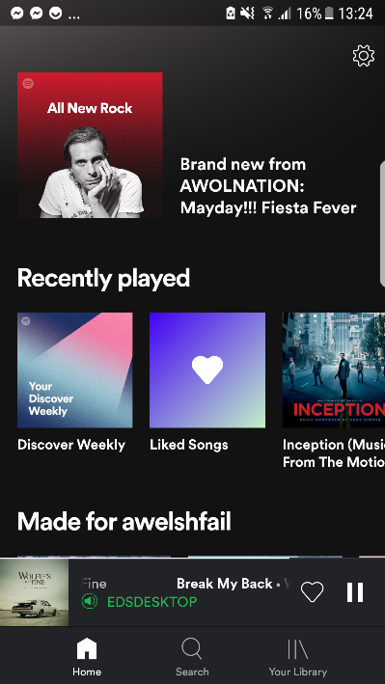

*Figure 1.3.2*

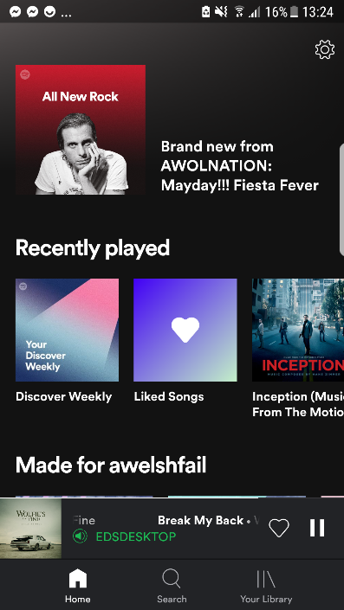

*Figure 1.3.1*



*Figure 1.3.3*

Observation 1: App demonstrates good adherence to Nielsen’s 3rd heuristic by always having the home button on screen allowing users to quickly and easily leave an unwanted page or function. (see screenshot in Figure 1.3.1)

Observation 2: App demonstrates good adherence to Nielsen’s 1st heuristic by having the current song displayed on screen to ensure the user is always aware of what the app is currently playing. (see screenshot in Figure 1.3.2)

Observation 3: App demonstrates good adherence to Nielsen’s 2nd heuristic by having a heart icon indicating how to favourite/like a song and the traditional sideways triangle and two columns to indicate play and pause respectively. (see screenshot in Figure 1.3.3)

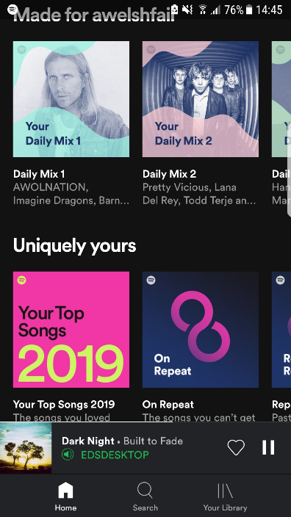

*Figure 1.3.6*

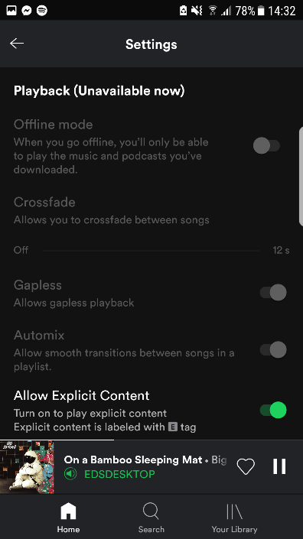

*Figure 1.3.5*



*Figure 1.3.4*

Observation 4: App demonstrates good adherence to Nielsen’s 8th heuristic by keeping the design simple using large images rather than a list of words. (seen in screenshot Figure 1.3.4)

Observation 5: App demonstrates good adherence to Nielsen’s 2nd heuristic by using day to day language that isn’t going to confuse the user. (seen in screenshot Figure 1.3.5)

Observation 6: App violates Nielsen’s 7th heuristic by not allowing the user to customise what they see on the home page. Thus restricting a user easy access to the content they value highest. (see in screenshot Figure 1.3.6)



*Figure 1.3.7*

Observation 7: App violates Nielsen’s 1th heuristic by not informing the user why certain options are currently unavailable. (see screenshot Figure 1.3.7)

YouTube Music:

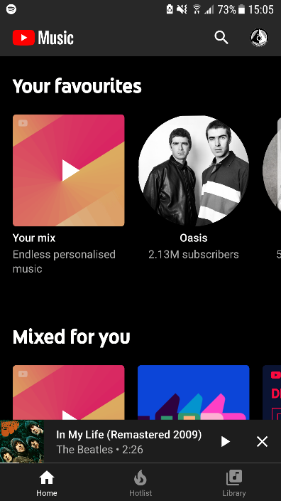

*Figure 1.3.9*

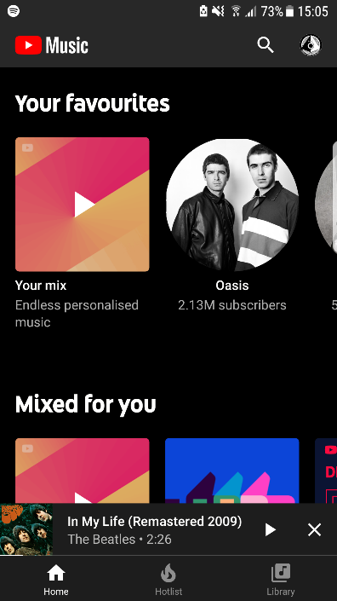

*Figure 1.3.8*

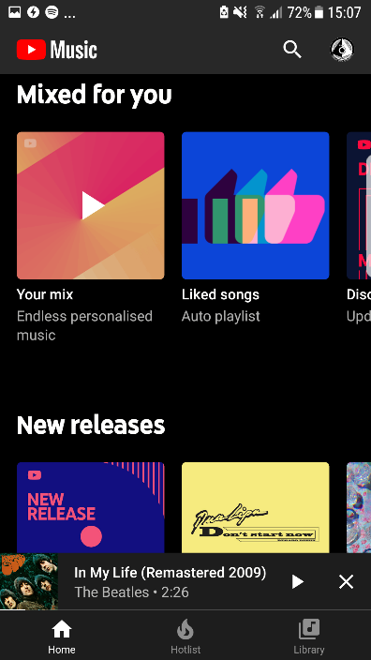

*Figure 1.3.10*

Observation 2*: App demonstrates good adherence to Nielsen’s 1st heuristic by having the current song displayed on screen to ensure the user is always aware of what the app is currently playing. (see screenshot in Figure 1.3.8)

Observation 1*: App demonstrates good adherence to Nielsen’s 3rd heuristic by always having the home button on screen allowing users to quickly and easily leave an unwanted page or function. (see screenshot in Figure 1.3.9)

Observation 4*: App demonstrates good adherence to Nielsen’s 8th heuristic by keeping the design simple using large images rather than a list of words. (seen in screenshot Figure 1.3.10)



*Figure 1.3.12*



*Figure 1.3.11*

Observation 3*: App demonstrates good adherence to Nielsen’s 2nd heuristic the traditional sideways triangle and two columns to indicate play and pause respectively. (see screenshot in Figure 1.3.11)

Observation 8: App violates Nielsen’s 7th heuristic by not allowing the user to like a song . This function is often used and should always be easy to reach . (see in screenshot Figure 1.3.12)

Apple Music:

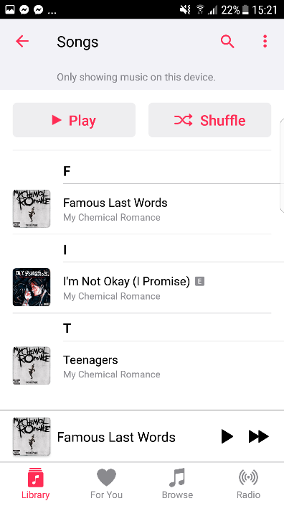

*Figure 1.3.14*

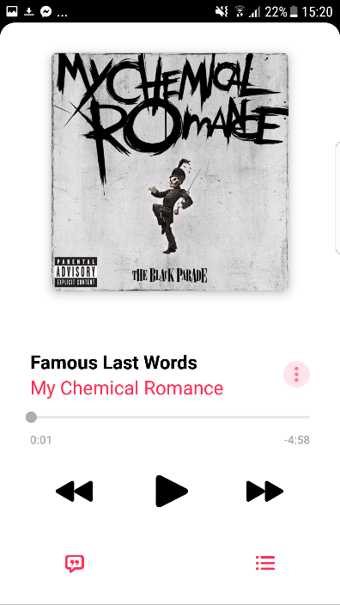

*Figure 1.3.15*

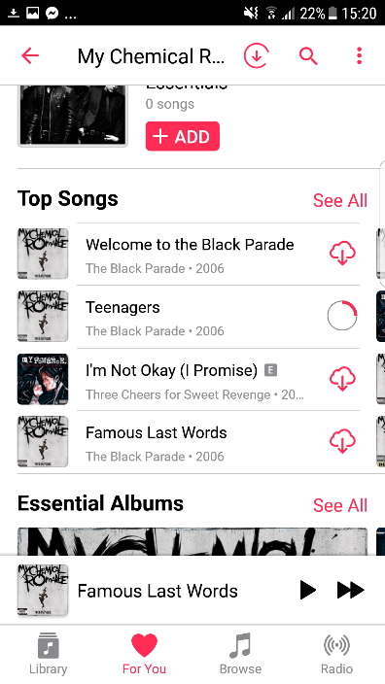

*Figure 1.3.13*

Observation 2*: App demonstrates good adherence to Nielsen’s 1st heuristic by having the current song displayed on screen to ensure the user is always aware of what the app is currently playing. (see screenshot in Figure 1.3.13)

Observation 9: App violates Nielsen’s 2nd heuristic by having the heart logo than traditionally indicates liked songs and instead uses it for recommended music confusing the user. (see screenshot in Figure 1.3.14)

Observation 3*: App demonstrates good adherence to Nielsen’s 2nd heuristic the traditional sideways triangle and two columns to indicate play and pause respectively. (see screenshot in Figure 1.3.15)

**Chapter 2: Prototyping**

Section 2.1: “My Vision”

App Functionality

My app will:

* allow users to save songs as favourite and places said song in users library, preserving Theme 1
* allow users to quickly navigate to commonly used functions and screens using a simple four symbol menu that is always at the bottom of the screen, preserving Theme 2
* allow users to use multiple devices at once addressing Theme 6
* allow users to customise their home screens with playlists and functions that are important to the user addressing Theme 7
* allow users to queue songs, preserving Theme 16
* allow users to view a recommended page that finds songs and artists the user may enjoy, enhancing Theme 17
* provides the user with the option of selecting favourite artists and songs to be used to recommend other music the user may enjoy, preserving Theme 11
* provides a simple and easy to understand time slider to select a point in the song addressing Theme 13
* allows users to follow other users to see what their friends are listening to addressing Theme 18
* allow users to save songs to playlists, preserving Theme 1*
* allow users to visit a friends page that shows users what their friends are currently listening to, have recently favourited and view other users playlists, addressing and enhancing Theme 18
* allow user to use a simple search bar to search for music and artists, preserving Theme 19
* search page will have simple option to choose a specific genre of music to search for, preserving Theme 4
* allow users to repeat songs, preserving Theme 10

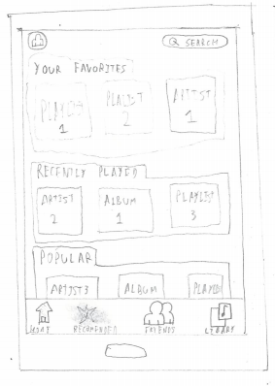

*Figure 2.1.1*

Preserving Observation 4 by having the design simple using large image tiles rather than words.

Preserving Observation 1 by having the home button always available to the user allowing users to easily leave an unwanted page or function.

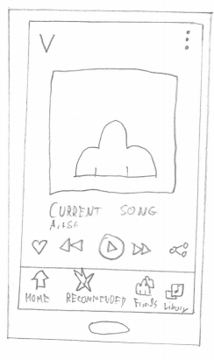

*Figure 2.1.2*

Preserving Observation 3 by having a heart icon indicating how to favourite/like a song and the traditional sideways triangle and two columns to indicate play.

Addresses Observation 9 by using sticking to normal convention and using symbols immediately recognisable e.g. having the home button be a logo of a simple house.

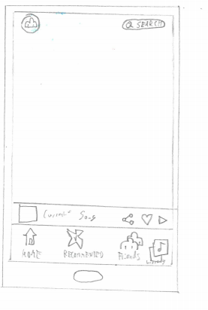

*Figure 2.1.3\**

Addresses Observation 8 by always placing the like function in an obvious and easy to reach position.

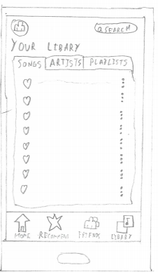

*Figure 2.1.4*

Preserving Observation 5 by having simple day to day language that wont confuse the user.

*\*Figure 2.1.3 was a latter addition to the design. The playing bar will be visible on the majority of the apps pages. It will always be visible when on of the 4 main function pages (Home, Recommended, Friends and Library*

Section 2.2: “My Test Plan”

*To be read out to the participants at the beginning of the test*: Hello and thank you for agreeing to test our new music app. Today you shall be given several tasks to perform within the app. The speed and ease in which you complete this task will assist the development team in bettering the apps aesthetic and interface. After each task please write down your thoughts and experience to better help the development team improve the app. Thank you.

*Test 1:*

*Preparation:* Tester should ensure the app is at the home page.

*Scenario:* “You’ve just added a new song to your library”

*Task:* “Now, show me how you would share this song with a friend”

*Test 2:*

*Preparation:* Tester should ensure the app is at the home page and the current song is indicating its playing.

*Scenario:* “You are enjoying the currently playing song”

*Task:* “Now, show me how to favourite the playing song”

*Test 3:*

*Preparation:* Tester should ensure the app is at the home page.

*Scenario: “*You wish to make some changes to background systems such as network usage”

*Task:* “Show me how you would access the settings menu”

Section 2.3: “My Low Level Prototype”

Axure Cloud Link: https://9q1b8h.axshare.com

Section 2.4: “Test Results”

*Participant 1:*

*SUS Score*

|  |  |  |  |  |
| --- | --- | --- | --- | --- |
|  |  |  | **X** |  |

Strongly Disagree

Strongly Agree

1. I think I would like to use this system frequently.

4

2

3

5

1

|  |  |  |  |  |
| --- | --- | --- | --- | --- |
| **X** |  |  |  |  |

1. I found the system unnecessarily complex

4

2

3

5

1

|  |  |  |  |  |
| --- | --- | --- | --- | --- |
|  |  |  | **X** |  |

1. I thought the system was easy to use

4

2

3

5

1

|  |  |  |  |  |
| --- | --- | --- | --- | --- |
| **X** |  |  |  |  |

1. I think that I would need the support of a technical person to be able to use this system.

4

2

3

5

1

|  |  |  |  |  |
| --- | --- | --- | --- | --- |
|  |  |  | **X** |  |

1. I found the various functions in this system were well integrated.

1

4

2

3

5

|  |  |  |  |  |
| --- | --- | --- | --- | --- |
| **X** |  |  |  |  |

1. I thought there was too much inconsistency in this system.

4

2

3

5

1

|  |  |  |  |  |
| --- | --- | --- | --- | --- |
|  |  |  |  | **X** |

1. I would imagine that most people would learn to use this system very quickly.

1

4

2

3

5

|  |  |  |  |  |
| --- | --- | --- | --- | --- |
| **X** |  |  |  |  |

1. I found the system very cumbersome to use.

1

4

2

3

5

|  |  |  |  |  |
| --- | --- | --- | --- | --- |
|  |  |  |  | **X** |

1. I felt very confident using the system.

4

2

3

5

1

|  |  |  |  |  |
| --- | --- | --- | --- | --- |
| **X** |  |  |  |  |

1. I needed to learn a lot of things before I could get going with this system.

1

4

2

3

5

**System Usability Score**

|  |  |
| --- | --- |
| **Question** | **Score** |
| 1. I think I would like to use this system frequently | 4 |
| 1. I found the system unnecessarily complex | 1 |
| 1. I thought the system was easy to use | 4 |
| 1. I think that I would need the support of a technical person to be able to use this system | 1 |
| 1. I found the various functions in this system were well integrated | 4 |
| 1. I thought there was too much inconsistency in this system | 1 |
| 1. I would imagine that most people would learn to use this system very quickly | 5 |
| 1. I found the system very cumbersome to use | 1 |
| 1. I felt very confident using the system | 5 |
| 1. I needed to learn a lot of things before I could get going with this system | 1 |
| **SUS Total** | **90** |

**SUS Calculations**

Question 1: 4 – 1 = 3

Question 2: 5 – 1 = 4

Question 3: 4 – 1 = 3

Question 4: 5 – 1 = 4

Question 5: 4 – 1 = 3

Question 6: 5 – 1 = 4

Question 7: 5 – 1 = 4

Question 8: 5 – 1 = 4

Question 9: 5 – 1 = 3

Question 10: 5 – 1 = 4

SUS Total: (3 + 4 + 3 + 4 + 3 + 4 + 4 + 4 + 3+ 4) * 2.5 = 90

**Participant 1 Comments and Feedback**

Participant 1 liked the immediate familiarity with the layout and functions from platform conventions.

Participant 1 did not like the style and look of the app “Too bland, needs more colour in my opinion”

Participant 1 admitted never having used the share function in a music app but had little issues completing Task 1

*Participant 2:*

*SUS Score*

|  |  |  |  |  |
| --- | --- | --- | --- | --- |
|  |  | **X** |  |  |

Strongly Disagree

Strongly Agree

1. I think I would like to use this system frequently.

4

2

3

5

1

|  |  |  |  |  |
| --- | --- | --- | --- | --- |
| **X** |  |  |  |  |

1. I found the system unnecessarily complex

4

2

3

5

1

|  |  |  |  |  |
| --- | --- | --- | --- | --- |
|  |  |  |  | **X** |

1. I thought the system was easy to use

4

2

3

5

1

|  |  |  |  |  |
| --- | --- | --- | --- | --- |
|  | **X** |  |  |  |

1. I think that I would need the support of a technical person to be able to use this system.

4

2

3

5

1

|  |  |  |  |  |
| --- | --- | --- | --- | --- |
|  |  |  | **X** |  |

1. I found the various functions in this system were well integrated.

1

4

2

3

5

|  |  |  |  |  |
| --- | --- | --- | --- | --- |
| **X** |  |  |  |  |

1. I thought there was too much inconsistency in this system.

4

2

3

5

1

|  |  |  |  |  |
| --- | --- | --- | --- | --- |
|  |  |  |  | **X** |

1. I would imagine that most people would learn to use this system very quickly.

1

4

2

3

5

|  |  |  |  |  |
| --- | --- | --- | --- | --- |
| **X** |  |  |  |  |

1. I found the system very cumbersome to use.

1

4

2

3

5

|  |  |  |  |  |
| --- | --- | --- | --- | --- |
|  |  | **X** |  |  |

1. I felt very confident using the system.

4

2

3

5

1

|  |  |  |  |  |
| --- | --- | --- | --- | --- |
| **X** |  |  |  |  |

1. I needed to learn a lot of things before I could get going with this system.

1

4

2

3

5

**System Usability Score**

|  |  |
| --- | --- |
| **Question** | **Score** |
| 1. I think I would like to use this system frequently | 3 |
| 1. I found the system unnecessarily complex | 1 |
| 1. I thought the system was easy to use | 5 |
| 1. I think that I would need the support of a technical person to be able to use this system | 2 |
| 1. I found the various functions in this system were well integrated | 4 |
| 1. I thought there was too much inconsistency in this system | 1 |
| 1. I would imagine that most people would learn to use this system very quickly | 5 |
| 1. I found the system very cumbersome to use | 1 |
| 1. I felt very confident using the system | 3 |
| 1. I needed to learn a lot of things before I could get going with this system | 1 |
| **SUS Total** | **82.5** |

**SUS Calculations**

Question 1: 3 – 1 = 2

Question 2: 5 – 1 = 4

Question 3: 5 – 1 = 4

Question 4: 5 – 3 = 2

Question 5: 4 – 1 = 3

Question 6: 5 – 1 = 4

Question 7: 5 – 1 = 4

Question 8: 5 – 1 = 4

Question 9: 5 – 3 = 2

Question 10: 5 – 1 = 4

SUS Total: (2 + 4 + 4 + 2 + 3 + 4 + 4 + 4 + 2+ 4) * 2.5 = 82.5

**Participant 2 Comments and Feedback**

Participant 2 felt comfortable with the layout and functions due to experience with other apps.

Participant 2 liked the minimalist style.

Participant 2 would have liked the ability to share via a link.

*Participant 3:*

*SUS Score*

|  |  |  |  |  |
| --- | --- | --- | --- | --- |
|  |  |  | **X** |  |

Strongly Disagree

Strongly Agree

1. I think I would like to use this system frequently.

4

2

3

5

1

|  |  |  |  |  |
| --- | --- | --- | --- | --- |
| **X** |  |  |  |  |

1. I found the system unnecessarily complex

4

2

3

5

1

|  |  |  |  |  |
| --- | --- | --- | --- | --- |
|  |  |  |  | **X** |

1. I thought the system was easy to use

4

2

3

5

1

|  |  |  |  |  |
| --- | --- | --- | --- | --- |
| **X** |  |  |  |  |

1. I think that I would need the support of a technical person to be able to use this system.

4

2

3

5

1

|  |  |  |  |  |
| --- | --- | --- | --- | --- |
|  |  |  | **X** |  |

1. I found the various functions in this system were well integrated.

1

4

2

3

5

|  |  |  |  |  |
| --- | --- | --- | --- | --- |
| **X** |  |  |  |  |

1. I thought there was too much inconsistency in this system.

4

2

3

5

1

|  |  |  |  |  |
| --- | --- | --- | --- | --- |
|  |  |  |  | **X** |

1. I would imagine that most people would learn to use this system very quickly.

1

4

2

3

5

|  |  |  |  |  |
| --- | --- | --- | --- | --- |
| **X** |  |  |  |  |

1. I found the system very cumbersome to use.

1

4

2

3

5

|  |  |  |  |  |
| --- | --- | --- | --- | --- |
|  |  |  |  | **X** |

1. I felt very confident using the system.

4

2

3

5

1

|  |  |  |  |  |
| --- | --- | --- | --- | --- |
|  | **X** |  |  |  |

1. I needed to learn a lot of things before I could get going with this system.

1

4

2

3

5

|  |  |
| --- | --- |
| **Question** | **Score** |
| 1. I think I would like to use this system frequently | 4 |
| 1. I found the system unnecessarily complex | 1 |
| 1. I thought the system was easy to use | 5 |
| 1. I think that I would need the support of a technical person to be able to use this system | 1 |
| 1. I found the various functions in this system were well integrated | 4 |
| 1. I thought there was too much inconsistency in this system | 1 |
| 1. I would imagine that most people would learn to use this system very quickly | 5 |
| 1. I found the system very cumbersome to use | 1 |
| 1. I felt very confident using the system | 5 |
| 1. I needed to learn a lot of things before I could get going with this system | 2 |
| **SUS Total** | **87.5** |

**System Usability Score**

**SUS Calculations**

Question 1: 4– 1 = 3

Question 2: 5 – 1 = 4

Question 3: 5 – 1 = 4

Question 4: 5 – 1 = 4

Question 5: 4 – 1 = 3

Question 6: 5 – 1 = 4

Question 7: 5 – 1 = 4

Question 8: 5 – 1 = 4

Question 9: 5 – 3 = 2

Question 10: 5 – 2= 3

SUS Total: (3 + 4 + 4 + 4 + 3 + 4 + 4 + 4 + 2+ 3) * 2.5 = 87.5

**Participant 3 Comments and Feedback**

Participant 3 would have liked a little more colour in the design, they thought it was too “Boardroom” and dull.

Participant 3 liked the social aspect of the app and would like to see that further developed.